Molecular Diagnostic Template for Laboratories

A. PURPOSE FOR SUBMISSION

Emergency Use Authorization (EUA) request for use of FloodLAMP to be performed for the in vitro qualitative detection of RNA from the SARS-CoV-2 in anterior nares swab specimens and saliva samples from individuals [suspected of COVID-19 by their healthcare provider][as recommended for testing by public health authority guidelines for screening of asymptomatic individuals]. FloodLAMP will be performed in CLIA-certified, high-complexity laboratories. Additional testing and confirmation procedures should be performed in consultation with public health and/or other authorities to whom reporting is required. Positive results should also be reported in accordance with local, state, and federal regulations.

B. MEASURAND
Specific nucleic acid sequences in the ORF1a and nucleocapsid genes of SARS-CoV-2, targeted by the As1e and N2 primer sets.

C. LABORATORY/SPONSOR

Randall J. True
Founder and CEO
FloodLAMP Biotechnologies, a DE Public Benefit Corporation
Phone: (415) 269-2974
Email: randy@floodlamp.bio

Mailing Address:
4860 Alpine Rd.
Portola Valley, CA 94028

Laboratory Address:
FloodLAMP.bio at MBC Biolabs
San Carlos, CA 94070

D. REGULATORY INFORMATION

Approval/Clearance Status:

FloodLAMP is not cleared, CLIA-waived, approved, or subject to an approved investigational device exemption.

Product Code:
QJR

E. PROPOSED INTENDED USE

1) Intended Use:
The FloodLAMP Glass Milk Test is a reverse transcriptase loop-mediated isothermal amplification (RT-LAMP) test intended for the qualitative detection of RNA from SARS-CoV-2 in saliva and anterior nares (nasal) swab specimens. Testing is limited to screening of asymptomatic individuals. Testing is limited to laboratories certified under the Clinical Laboratory Improvement Amendments of 1988 (CLIA), 42 U.S.C. §263a, to perform high complexity tests, or by similarly qualified non-U.S. laboratories. Sample pooling is at a baseline level of 10, with on-site and at-home modalities. Pooling of pools to levels greater than 10 will be investigated pending LoD determination and validation studies.

Results are for the identification of SARS-CoV-2 RNA. The SARS-CoV-2 RNA is generally detectable in upper respiratory specimens during the acute phase of infection. Positive results are indicative of the presence of SARS-CoV-2 RNA; clinical correlation with patient history and other diagnostic information is necessary to determine patient infection status. Positive results do not rule out bacterial infection or co-infection with other viruses. The agent detected may not be the definite cause of disease. Laboratories within the United States and its territories are required to report all positive results to the appropriate public health authorities.

Negative results do not preclude SARS-CoV-2 infection and should not be used as the sole basis for patient management decisions. Negative results must be combined with clinical observations, patient history, and epidemiological information. FloodLAMP Glass Milk Test is intended to be used on normal and clear saliva that naturally forms in the mouth, not for other lower respiratory tract specimens such as sputum.

The assay is intended for use by qualified and trained clinical laboratory personnel specifically instructed and trained in the techniques of real-time PCR and in vitro diagnostic procedures. The assay is only for use under the Food and Drug Administration’s Emergency Use Authorization.
Use of the FloodLAMP Glass Milk Test in a general, asymptomatic screening population is intended to be used as part of an infection control plan, that may include additional preventative measures, such as a predefined serial testing plan or directed testing of high-risk individuals. Negative results should be considered presumptive and do not preclude current or future infection obtained through community transmission or other exposures. Negative results must be considered in the context of an individual’s recent exposures, history, presence of clinical signs and symptoms consistent with COVID-19.

2) Reagents Used with Test:
The FloodLAMP Glass Milk test is to be used with the following reagents and no specialized instruments. Only ordinary laboratory equipment such as pipettes, centrifuges, and heaters are needed.

Table 1: Validated reagents used with Test
Item | Chemical Composition | Vendor | Catalog number
TCEP | tris(2-carboxyethyl)phosphine hydrochloride | Sigma-Aldrich  Millipore Sigma | 646547-10X1ML  580567
EDTA | Ethylenediaminetetraacetic acid | Thermo Fisher | 15575020
NaOH | Sodium Hydroxide | Sigma-Aldrich | SX0607N-6
Ultrapure Water | Ultrapure Water, DNAse RNAse free | Thermo Fisher | 10977015
Tris-HCl | TRIS hydrochloride, 1M pH 8.0 | Thermo Fisher | AM9855G
TE Buffer | TRIS hydrochloride (10mM) and EDTA (1mM) | Sigma-Aldrich | 93283
1X PBS | monobasic potassium phosphate, sodium | Thermo Fisher | 10010049
 | chloride, and dibasic sodium phosphate
NaI | Sodium iodide | Sigma-Aldrich | 793558
HCl | Hydrochloric acid | Sigma-Aldrich | 320331
Triton X-100 | t-Octylphenoxypolyethoxyethanol | Sigma-Aldrich | T8787-50ML
Silica | Silicon Dioxide, 325 Mesh | Sigma-Aldrich | SI108
Guanidine | Guanidine Hydrochloride | Sigma-Aldrich | SRE0066
LAMP MM | Colorimetric LAMP Master Mix | NEB | M1804

3) Prepared Solutions Used with Test:

Table 2: Inactivation Solution
Component | Concentration | Volume
TCEP | 0.5 M | 10 mL
EDTA | 0.5 M | 4 mL
NaOH | 10 N | 2.3 mL
Ultrapure Water |  | 3.7 mL
Final Volume 20 mL

Table 3: Binding Solution
Component | Concentration | Volume / Mass
NaI |  | 45 g
Ultrapure Water |  | to 48.5 mL
HCl | 1 N | 0.5 mL
Triton X-100 |  | 1.0 mL
Final Volume 50 mL

Table 4: Glass Milk - Under Development
Component | Concentration | Volume / Mass
Silica |  | 500 g
HCl | 10% | 100 mL
dH20 |  | 2400 mL
TE Buffer |  | 500 mL
Final Volume 200 mL

Table 5: Primers used for FloodLAMP "AN" Primer Mix
Target | Primer | Sequence
As1e | As1e_FIP | TCAGCACACAAAGCCAAAAATTTATTTTTCTGTGCAAAGGAAATTAAGGAG
 | As1e_BIP | TATTGGTGGAGCTAAACTTAAAGCCTTTTCTGTACAATCCCTTTGAGTG
 | As1_F3 | CGGTGGACAAATTGTCAC
 | As1_B3 | TTACAAGCTTAAAGAATGTCTGAACACT
 | As1_LF | TTACAAGCTTAAAGAATGTCTGAACACT
 | As1_LB | TTGAATTTAGGTGAAACATTTGTCACG
N2 | N2-FIP | TTCCGAAGAACGCTGAAGCGGAACTGATTACAAACATTGGCC
 | N2-BIP | CGCATTGGCATGGAAGTCACAATTTGATGGCACCTGTGTA
 | N2-F3 | ACCAGGAACTAATCAGACAAG
 | N2-B3 | GACTTGATCTTTGAAATTTGGATCT
 | N2-LF | GGGGGCAAATTGTGCAATTTG
 | N2-LB | CTTCGGGAACGTGGTTGACC

Table 6: 10X Primer Mix
Primer | Volume (400 reactions)
As1e_FIP (100uM) | 160 µL
As1e_BIP (100uM) | 160 µL
As1_F3 (100uM) | 20 µL
As1_B3 (100uM) | 20 µL
As1_LF (100uM) | 40 µL
As1_LB (100uM) | 40 µL
N2-FIP (100uM) | 160 µL
N2-BIP (100uM) | 160 µL
N2-F3 (100uM) | 20 µL
N2-B3 (100uM) | 20 µL
N2-LF (100uM) | 40 µL
N2-LB (100uM) | 40 µL
Add Ultrapure Water | 120 µL
Final Volume 1000 µL

Table 7: Primer Solution
Component | Volume (1 reaction) | Volume (100 reactions)
Ultrapure Water | 7.5 µL | 750 µL
Guanidine (400 mM) | 2.5 µL | 250 µL
10X Primer Mix | 2.5 µL | 250 µL
Final Volume 1250 mL

F. DEVICE DESCRIPTION AND TEST PRINCIPLE

1) Product Overview/Test Principle:

The FloodLAMP Glass Milk Test is a method for SARS-CoV-2 detection that comprises 3 steps: 1) sample inactivation and preservation, 2) nucleic acid purification and concentration, and 3) colorimetric RT-LAMP amplification. It can be broadly implemented as it (1) utilizes very low cost, readily available bulk reagents for inactivation and purification, (2) does not require any instrumentation for assay processing or readout, and (3) has high sensitivity enabling sample pooling to be utilized. Thus, the low cost and low barrier to deployment of the FloodLAMP Glass Milk Test means that it can scale quickly to very high levels.

2) Description of Test Steps:

Sample Inactivation
Starting with raw saliva or anterior nares swab extract:
- 100X Inactivation Solution is added to sample.
- Sample is vortexed to mix.
- Sample is heated in 95°C water bath or dry heat block for 8 minutes.
- Sample is placed on ice for at least 4 minutes.
- Sample is spun in centrifuge at 5krpm for 4 minutes.
- Top 90% of the sample is transferred to a new tube for subsequent processing and/or storage.
- Store samples at 2-8°C until sample transport or processing (up to 72 hours) or at -20°C for 2-4 weeks, or at -80°C for longer term storage.

Glass Milk Purification
- Glass Milk is added to the Binding Solution at a ratio of 1:50.
- Glass Milk + Binding Solution is vortexed to mix.
- 255 µL of Mixture is added to 500 µL of sample, in 1.5 mL microcentrifuge tubes or in wells of a deepwell plate.
- Sample is incubated for 10 minutes, with periodic mixing.
- Sample is spun down for 1 minute to pellet glass milk.
- Supernatant is removed.
- 80% Ethanol is added and then removed to wash pellet and perform liquid exchange.
- 100 µL of 80% ethanol is added, pellet resuspended and resuspension transferred to 200 µL PCR tubes (either to strips of 8 PCR tubes or to a PCR plate).
- Strips are capped (plates sealed) and spun down.
- Supernatant is removed.
- Tubes (plate) with nucleic acid bound silica pellet is placed on a 65°C heat block and heated for 5 minutes or until pellets have dry, chalky appearance.

LAMP Amplification
- On ice or in cold block, prepare LAMP Reaction Mix by combining 12.5 µL per reaction LAMP Master Mix (NEB 1804) with 12.5 µL of Primer Solution (per reaction: 7.5 µL water, 2.5 µL 400 mM Guanidine Hydrochloride , 2.5 µL 10X Primer Mix).
- 25 µL of LAMP Reaction Mix is added directly to dried pellet in each PCR tube.
- Mix by pipette (avoid bubbles).
- Cap strip tubes (seal plate).
- Incubate on hot plate with PCR Tube dry block at 65°C for 25 minutes.
- Remove strip tubes (plate) and let cool for 2 minutes.
- Visually read the result by color of the PCR tube.

3) Control Material(s) to be Used:
Controls will be included with every batch of samples run.

Table 8: Purpose and frequency of controls to be used with Test
Control | Purpose | Frequency
Negative Control | To monitor for contamination during sample processing | Every batch of up to 93 samples
Positive Control | To monitor functioning of reagents | Every PCR plate with up to 93 samples or batch of strip tubes

1X Phosphate Buffered Saline + Inactivation Solution is used as a negative control (no template control). 1X Phosphate Buffered Saline + Inactivation Solution + Spike (Zeptometrix Inactivated Virions, BEI Cell Lysate, or Twist synthetic SARS-CoV-2 RNA) is used as positive control (see Controls in Supporting Data).

4) Assay results and interpretation:
All test controls should be examined prior to interpretation of patient results. If the controls are not valid, the sample results cannot be interpreted. Results will be interpreted according to Table 9.

Table 9: Test results and interpretation
Outcome | Color
Positive | Yellow
Negative | Pink
Invalid | Orange

Table 10: Image of Acceptable Binary Test results
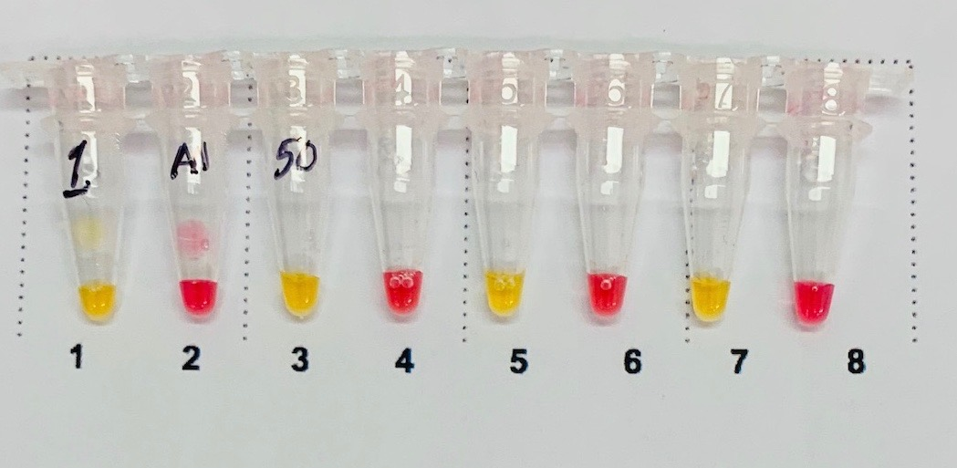

Invalid test results will be retested by repeating the purification and amplification on the inactivated sample. Results from retested samples will follow the same interpretation as listed in Table 9.

G. PERFORMANCE EVALUATION

1) Limit of Detection (LoD) - Analytical Sensitivity:
Specimens from presumed negative participants were collected and spiked with Zeptometrix inactivated virions prior to the inactivation step. This contrived positive sample was diluted in presumed negative inactivated samples to achieve the target concentrations for LoD assay runs (see Table 10 and Supporting Data).

Table 10: Limit of detection of Test
Concentration (copies/𝛍L) | Positive Samples Detected
4 | 100% (20/20)
2 | 100% (19/19)
As a part of the Xprize Rapid Test Competition, "proficiency plates" consisting of 157 blinded samples were run with the FloodLAMP Glass Milk Test. Purification was performed in deepwell plates and processing was performed with multichannel pipettes. Hands-on time per plate was approximately 1 hour. The Xprize samples were smaller volumes (100-200 µL) than typically used for the FloodLAMP Glass Milk Test (500 µL) and were not inactivated with the same TCEP Inactivation Solution. Notwithstanding these caveats, LoD and cross reactivity determination will be available after the results data is scored.
Below is an image of a completed FloodLAMP Glass Milk Test plate, including 8 alternating positive and negative controls in well positions H5-12.
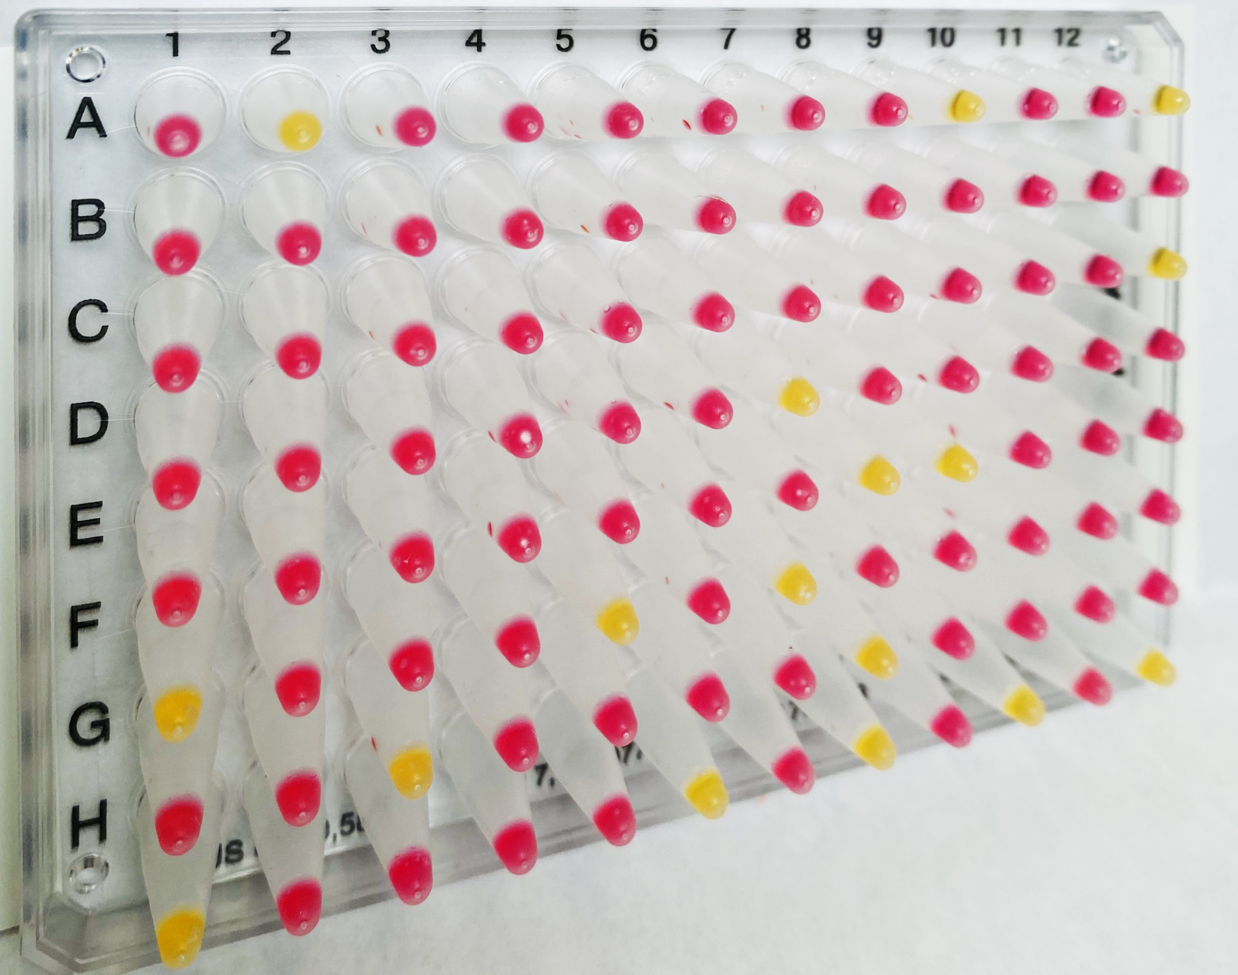

2) Inclusivity (analytical sensitivity): TBD

In silico inclusivity analysis to be performed by mapping the primers and probes to the complete SARS-CoV-2 genomes that are available in the current GISAID (Global Initiative on Sharing All Influenza Data) database. The rate of mismatches will be calculated and potential for amplification failure analyzed.

3) Cross-reactivity (analytical specificity): TBD

In silico cross reactivity analysis to be performed by aligning the primer sequences against sequences of coronaviruses related to SARS-Cov-2, as well as commonrespiratory pathogens. If any organisms show >80% overall match for the primer sets, wet testing of the following will be performed.

NR-52346 Quantitative PCR (qPCR) Control RNA from Inactivated SARS Coronavirus
NR-44228 Human respiratory syncytial virus , Genomic RNA from Human Respiratory Syncytial Virus, A1998/12-21
NR-45848 Genomic RNA from Influenza B Virus, B/Nevada/03/2011 (Victoria Lineage)
NR-49122 Genomic RNA from Human Metapneumovirus, TN/83-1211
HM-121 Streptococcus salivarius SK126

4) Clinical Evaluation:

Clinical specimens
The FloodLAMP Glass Milk Test has been performed on a single clinical positive saliva sample, however no concentration or comparator Ct values were available. The nucleic acid bound pellet was split evenly and the standard FloodLAMP Glass Milk Test colorimetric LAMP reaction was run on one set of 8 (duplicates of clinical positive and 6 controls) and the fluorimetric LAMP reaction (NEB E1700) was run on the 2nd set of 8 using an ABI QuantStudio 7 qPCR machine. SARS-CoV-2 was detected for the clinical positive samples in both sets, with expected results from all controls.

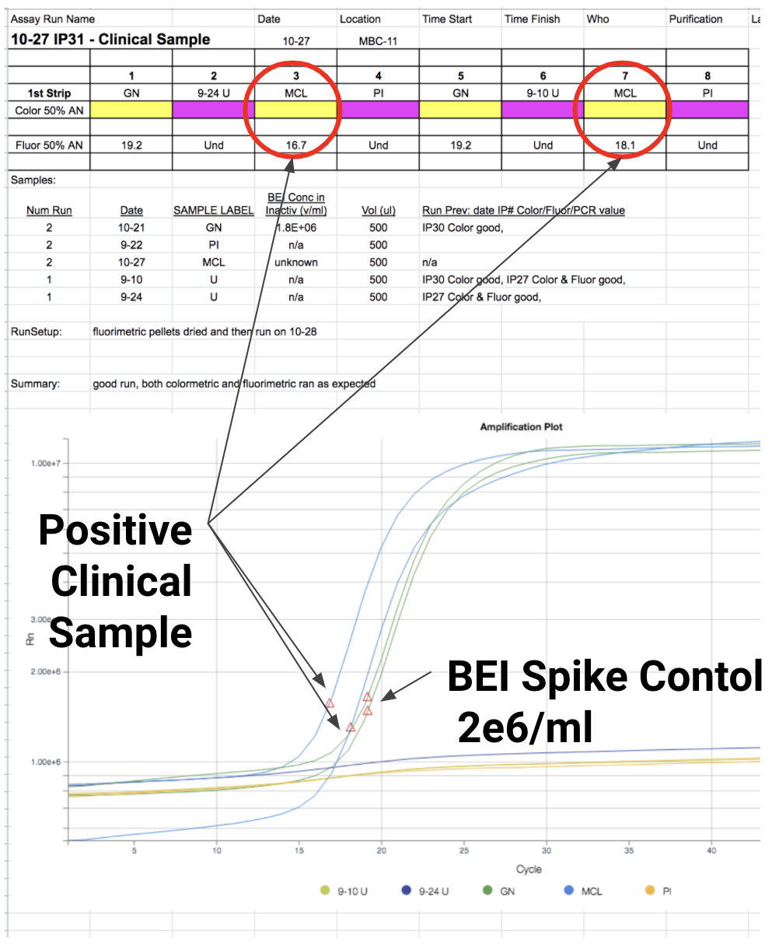

H. UNMET NEED ADDRESSED BY THE PRODUCT

This section will be completed by FDA.

I. APPROVED/CLEARED ALTERNATIVE PRODUCTS

Currently no methods for the detection of the SARS-CoV-2 have been approved/ cleared by FDA.

J. BENEFITS AND RISKS

This section will be completed by FDA.

K. FACT SHEET FOR HEALTHCARE PROVIDERS AND PATIENTS

Include proposed Fact Sheets for Patients and Healthcare Providers - see examples for authorized EUA tests on our website and templates will be made available.

L. INSTRUCTIONS FOR USE/ PROPOSED LABELING/PACKAGE INSERT

In lieu of a package insert or labeling please include your Laboratory SOP/protocol.

M. RECORD KEEPING AND REPORTING INFORMATION TO FDA

The laboratory will track adverse events and report to FDA under 21 CFR Part 803. A website is available to report on adverse events, and this website is referenced in the Fact Sheet for Health Care providers. The laboratory will maintain information on the performance of the test, and report to FDA any suspected change in performance of which they become aware. The laboratory will maintain records associated with this EUA and ensure these records are maintained until notified by FDA. Such records will be made available to FDA for inspection upon request.

